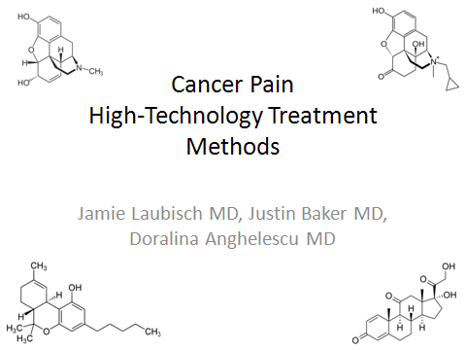
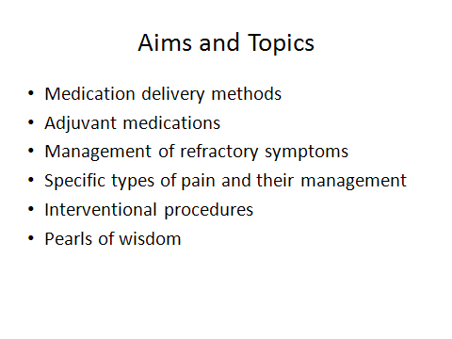
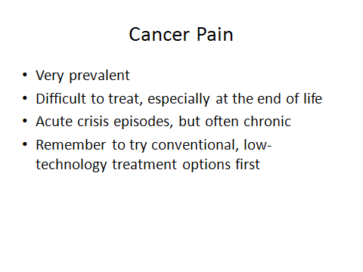
Remember to try all conventional, low-technology treatment options first. Cancer pain in general is very refractory because the cause of the pain often only gets worse with time. Start treatment early at the onset of pain to have the best chance at successfully controlling it.
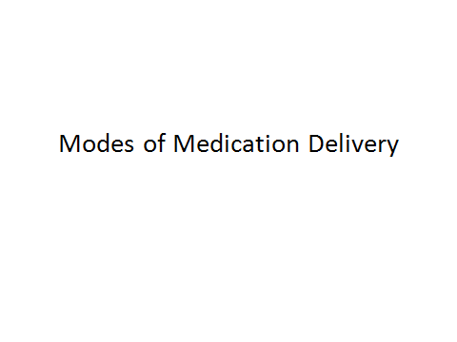
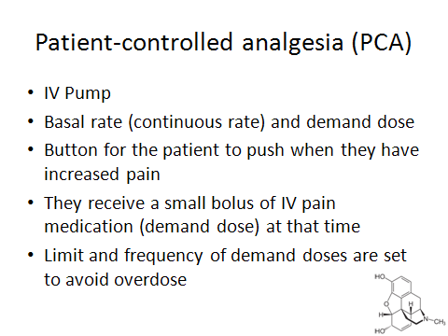
Patient-controlled analgesia or (PCA):
This is an IV pump that can deliver a continuous dose of a pain medication and a bolus or demand dose when the patient needs. There is a button for the patient to push when they have increased pain, before repositioning or any pain-invoking procedure and receive a small bolus of IV pain medication. A limit is set to the amount of bolus or demand doses a patient can receive in a certain amount of time. For example, there may be a limit for 2mg IV every 15 minutes as needed. Therefore, if they push the button before 15 minutes after the last dose, they will not receive more medication.
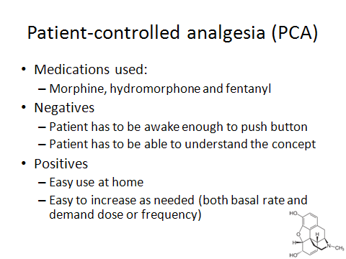
Medications available for PCA are morphine, hydromorphone and fentanyl and morphine is generally the first-line used. While this mode of delivery works very well, the patient has to be conscious and old enough to understand how and when to push the button. At the end-of-life it can be administered by nurses or family when they feel that patient is uncomfortable or in pain. This can be effective to avoid discomfort before a pain-invoking event or to alleviate breakthrough pain at the onset. This is very useful in the home setting as well to ensure continuous pain control and breakthrough relief 24 hours a day. The basal and bolus rate can easily be adjusted as needed at home to control pain and symptoms as they arise.

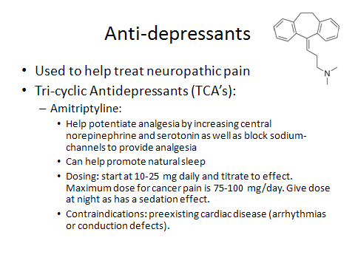
Anti-depressants are often used to help treat neuropathic pain. Tri-cyclic anti-depressants (TCA) such as Amitriptyline help potentiate analgesia, increase central norepinephrine and serotonin as well as block sodium-channels to provide analgesia. Additionally they can help promote natural sleep which can be an added benefit, so make sure they are taken at night. Caution in elderly or those with preexisting cardiac disease (arrhythmias or conduction defects) as it can worsen arrhythmias.
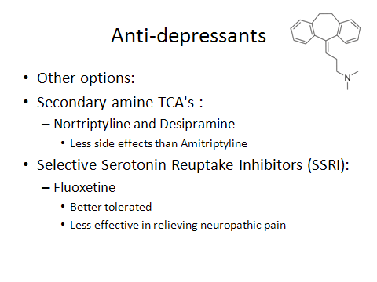
There are other classes of TCA’s called secondary TCA’s with fewer side effects that can be used as well. Selective Serotonin Reuptake Inhibitors (SSRI) such as Fluoxetine are better tolerated, but are less effective in relieving neuropathic pain. Try a TCA if the patient does not have any contraindications first for neuropathic pain. SSRI’s are still a great choice for anti-depressants in patient with pain.
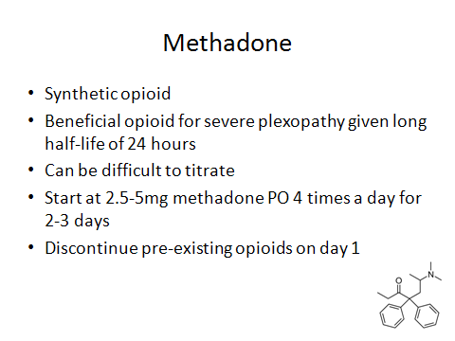
Methadone is a synthetic opioid with a long half-life of 24 hours. Given this fact, it is a good treatment option for chronic, non-acute pain especially for severe plexopathy. It can be difficult to titrate given its long half-life, but once on stable dosing it works very well as a basal, continuous oral option. When starting methadone, there are ranges of medications to use. Take into consideration how much medication the patient is currently on when choosing your starting dose.
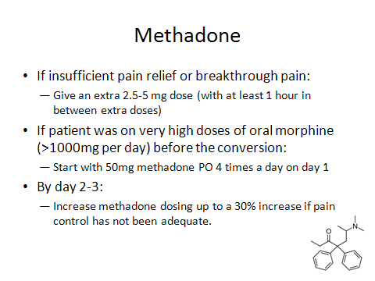
Once you are on methadone, if you have insufficient pain relief or breakthrough pain, give an extra 2.5-5 mg dose (with at least an hour in between extra doses). Try not to stack doses because the half-life is so long and the extra will add up over time. If the patient was on very high doses of oral morphine (>1000mg per day) before the conversion, start with 50mg methadone 4 times a day on day 1. Re-access each day and increase on day 2-3 after a steady level has been reached in the blood. If you need to increase, try by about 30% at a time. Again, wait a day or two after before increasing again and give breakthrough medications on top as needed.
CASE REPORT
Patient is a 5-month-old female diagnosed with a brain tumor called Atypical Teratoid Rhabdoid Tumor (ATRT). She underwent surgery, intra-ventricular shunt placement, and chemotherapy. The tumor continued to grow after surgery despite therapy and her shunt was no longer sufficient to relieve her increased intracranial pressure (ICP). She was nauseated with the slightest repositioning. To treat her increased ICP, meningeal irritation, and decrease her nausea, she was started on steroids and had significant improvement. She continued to clinically decline and eventually passed away, but the steroids helped control her nausea and ensure comfort.
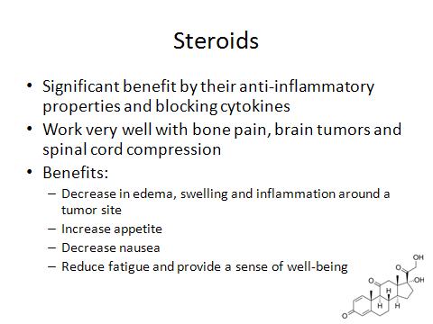
Steroids can help significantly with certain types of cancer pain given their anti-inflammatory properties and cytokine blocking effects. They often work very well with bone pain, brain tumors and spinal cord compression to help relieve pain as they decrease edema, swelling and inflammation around a tumor site. This helps alleviate pain and works very well for bone pain, spinal cord compression and brain tumors. Additional benefits are that they increase appetite, decrease nausea, reduce fatigue and provide a sense of well-being. However, remember if the cancer process is continuing to progress for a patient, they may only benefit for a short while until a tumor continues to grow, etc.

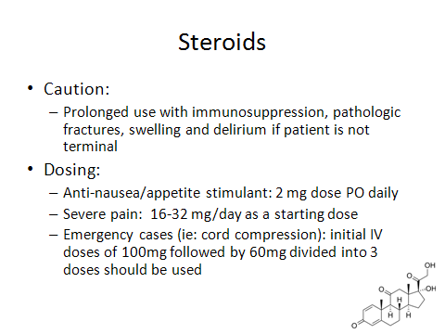
For patients who are not terminal, be cautious with prolonged use as they can cause immunosuppression, pathologic fractures, swelling and delirium. These are not of concern in end-of-life patients, but steroids can be used for cancer treatment in other phases of treatment as well. Make sure there are no drug interactions during chemotherapy and that they are not on a protocol that makes them unusable at certain times. The dosing varies on the symptom you are treating. Continue steroids until other treatment modalities are initiated and then decrease slowly.

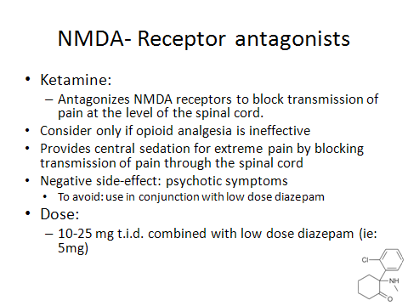
NMDA- Receptor antagonists, such as Ketamine, antagonizes NMDA receptors to block transmission of pain at the level of the spinal cord. This works well, but should be considered only if opioid analgesia is ineffective. It provides central sedation for extreme pain that is not relieved by conventional methods by blocking transmission of pain through the spinal cord. Its use is associated with a negative side-effect of psychotic symptoms, so use in conjunction with low dose diazepam to avoid negative symptoms. Patients also report nightmares up to months after its use, which is a normal side-effect.

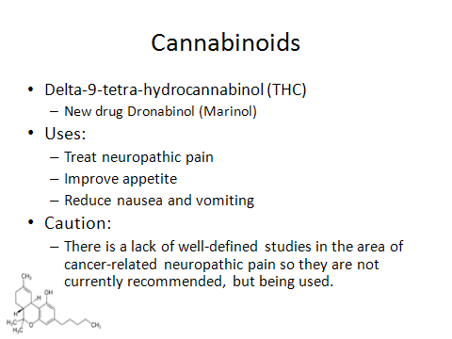
Cannabinoids or delta-9-tetra-hydrocannabinol (THC) is a new drug that is used to treat neuropathic pain. It is on the market as dronabinol or Marinol in the US and Canada. It also is used to improve appetite and reduce nausea and vomiting. Since there is currently a lack of well-defined studies in the area of cancer-related neuropathic pain so they are not recommended, but they are being used.

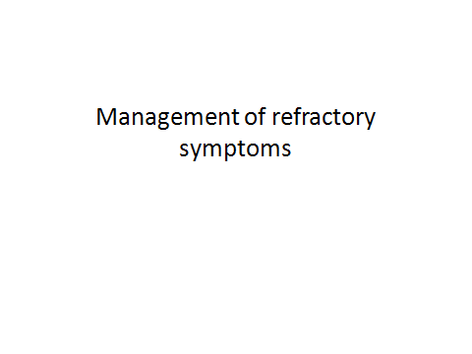
CASE REPORT
17 month-old female with progressive leukemia was on a hydromorphone PCA at the end of life. She developed severe opioid-induced constipation while on an enteral regimen and had significant abdominal distention and rectal prolapse. There were no enteral options given her clinical decline and enemas did not bring relief. She was given an injection of methylnaltrexone subcutaneously and stooled several times in less than 1 hour. This relieved her distention and rectal prolapse.

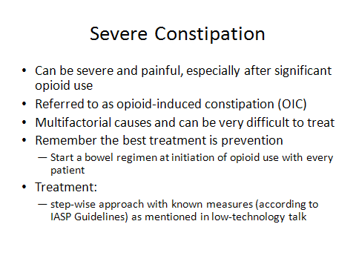
Constipation can be severe and painful, especially after significant opioid use, known as opioid-induced constipation (OIC). The causes are extremely multifactorial as discussed in the low technology lecture. Remember the best treatment is prevention, so start an enteral bowel regimen at the same time as opioids.

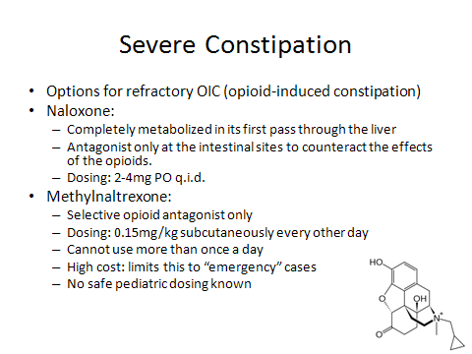
For severe cases of OIC, naloxone and methylnaltrexone are two options. Enteral naloxone can be used as it is completely metabolized in its first pass through the liver, so will be an antagonist only at the intestinal sites to counteract the effects of the opioids. The dosing of naloxone is 2-4mg PO q.i.d. Methylnaltrexone, a selective µ-opioid antagonist only medication that is very efficacious. It is delivered subcutaneously and has predictable effect within 120 minutes for 80% of patients. Its use is limited by its cost and is often used in “emergency” cases when intestinal paralysis and not merely obstruction is imminent. There are no safe pediatrics doses as of yet, but is being used with similar doses when necessitated.

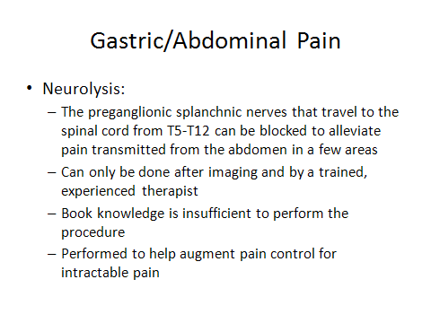
Gastric or Abdominal Pain is very prevalent with gastric cancers or abdominal metastasis. Additionally, it may be difficult to treat as many people with pancreatic and abdominal cancers often present later in the disease progression than other types of cancers. Neurolysis can be performed to help augment pain control for intractable pain. This is possible because the preganglionic splanchnic nerves that travel to the spinal cord from T5-T12 can be blocked to alleviate pain transmitted from the abdomen in a few areas. This is a difficult procedure and should only be done after imaging and by a trained, experienced therapist. Book knowledge is insufficient

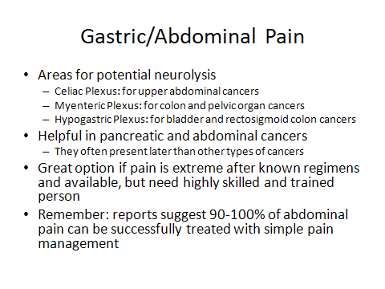
The areas for potential neurolysis are the following: celiac plexus: for upper abdominal cancers, myenteric plexus: for colon and pelvic organ cancers and hypogastric plexus: for bladder and rectosigmoid colon cancers. This is a great option if pain is extreme after known regimens and available, but required a highly skilled and trained person. Remember that reports suggest that 90-100% of abdominal pain can be successfully treated with simple pain management so optimize all medications before moving to this step.

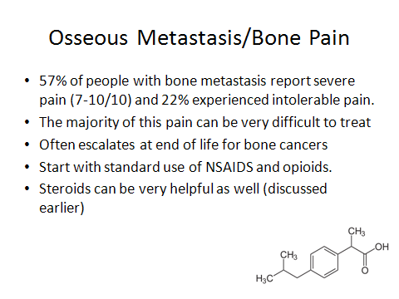
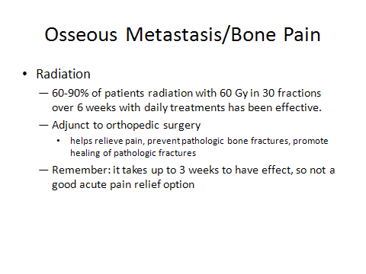
Radiation is a first-line treatment for bone pain. In 60-90% of patients, radiation with 60 Gy in 30 fractions over 6 weeks with daily treatments has been effective to decrease pain. It is viewed as an adjunct to orthopedic surgery as it helps relieve pain, prevent pathologic bone fractures and promote healing of pathologic fractures. The key is to start early and remember that it takes up to 3 weeks to have effect, so not a good acute pain relief option. It is worth pursuing during an acute episode to avoid continuation of the acute crisis and decrease chronic pain as well.

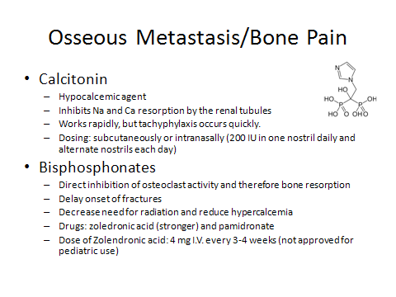
Calcitonin is a hypocalcemic agent which inhibits Na and Ca resorption by the renal tubules. It is beneficial, but tachyphylaxis occurs quickly. Bisphosphonates are used to delay onset of fractures, decrease need for radiation and reduce hypercalcemia. Drugs such as zoledronic acid (stronger) and pamidronate are used, but there is no safe dosing for pediatric patients.

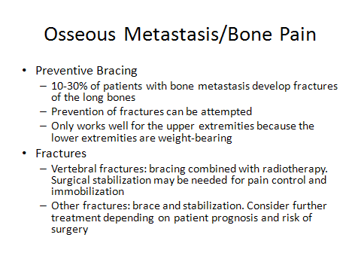
The treatment of fractures is difficult so many people have looked at preventive bracing for the 10-30% of patients with bone metastasis who develop fractures of the long bones. This only works well for the upper extremities because the lower extremities are weight-bearing and more difficult to prevent. Once a fracture occurs, they are treated depending on the location and the stability of the patient. Vertebral fractures are treated with bracing combined with radiotherapy. Sometimes surgical stabilization may be needed for pain control and immobilization. Other fractures are braced and stabilized. Consider further treatment depending on patient prognosis and risk of surgery

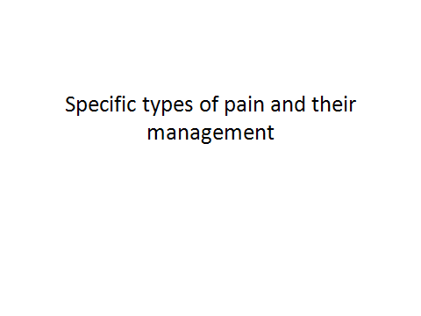
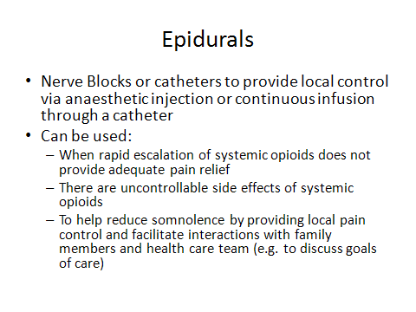
Epidurals are nerve blocks provide local control via anaesthetic injection or continuous infusion through a catheter. These can be used when you need to rapidly escalate doses of systemic opioids without adequate pain relief, there are uncontrollable side effects of systemic opioids, or to help reduce somnolence by providing local pain control and facilitate interactions with family members and health care team (e.g. to discuss goals of care). This can allow a patient to be more alert and interactive to improve their quality of life.
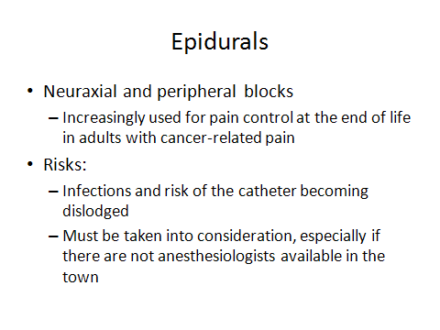
Neuraxial and peripheral nerve blocks are increasingly being used for pain control at the end of life in adults with cancer-related pain. There is a significant risk of infections as it is into the epidural space and if a clean environment cannot be provided, it is not a good option. Also, the risk of the catheter becoming dislodged must be taken into consideration, especially if there are not anesthesiologists available in the town.

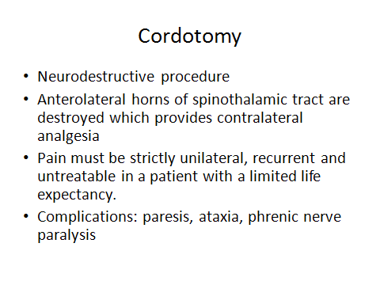
A cordotomy is a neurodestructive procedure where anterolateral horns of spinothalamic tract are destroyed, providing contralateral analgesia. This procedure works well, but the pain must be strictly unilateral, recurrent and untreatable in a patient with a limited life expectancy. If there is a chance that the patient will recover, this should never be considered as it is permanent. There are complications of paresis, ataxia, and phrenic nerve paralysis. It is an option, but should remain a last resort after other methods of pain management have failed.
CASE REPORT
Patient is a 16-year-old male who presents with a right arm mass, and he was found to have metastatic osteosarcoma. His arm pain was increasing despite very high levels of opioids. He became sedated secondary to the medications required to control his pain and could no longer go to school and his quality of life was declining. It was decided to amputate his right arm for improved pain control as the tumor continued to grow. After the post-operative period he required little medication to control his pain and was able to return to school and activities with friends and family.
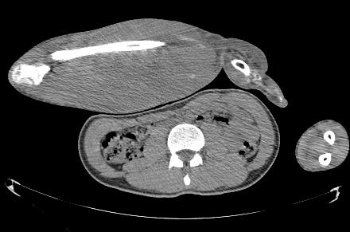
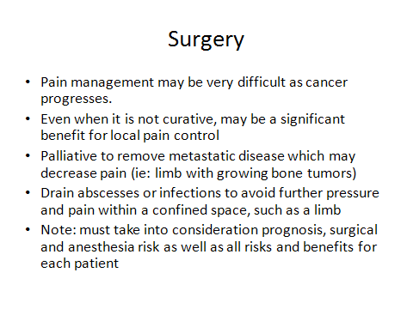
There are many ways surgery can help to reduce pain and symptoms in cancer patients. At times pain management may be very difficult as cancer progresses. Even when the intent of the surgery is not curative, there may be a significant benefit to surgery for local pain control. Palliative surgeries to remove metastatic disease may decrease pain, such as a limb with growing bone tumors. The drain of abscesses or infections to avoid further pressure and pain within a confined space, such as a limb can be very therapeutic. However, after chemotherapy, many patients have decreased heart function and many complications at baseline that make them high risk for anesthesia. Before each surgery, the prognosis, surgical and anesthesia risk as well as all risks and benefits for each patient must take into consideration.

